The Shaw/54th Memorial
National Park Service
U.S. Department of Interior
National Parks of Boston
This summer, the National Parks of Boston will offer a variety of programs focusing on the Shaw/54th Memorial, and the service and legacy of the MA 54th Regiment. All programs listed are open and FREE to the public. For specific times and locations, please visit http://go.nps.gov/todayinboston. For additional information, call (617) 742-5415 or follow us on social media.

Meet Me at the Shaw
Weekends during the summer at the Boston Common
How has the Shaw/54th Memorial been used since its dedication in 1897? This program will highlight some of the various groups and individuals that have utilized the Memorial as a place of commemoration, gatherings, and protest for more than 120 years.

Monuments and Memory
Throughout the year at various Boston locations
In October 2017, Massachusetts officials removed one of the only markers in the state dedicated to the Confederacy from Fort Warren on Georges Island. This program explores the history of the marker, the organization that erected it, and the broader national dialogue about how we remember the Civil War.

Community Organization and the 54th
Throughout the summer at the Boston Common and Faneuil Hall, Lower Level
In January of 1863, following the Emancipation Proclamation, the 54th Massachusetts officially began to accept recruits. With volunteers enlisting from all over the northern United States, the efforts of local community leaders proved invaluable. Join us as we explore how these local leaders spearheaded the recruitment of this historic unit.

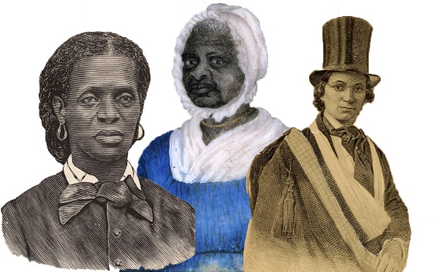
Mothers of Freedom
March 23, 1:00 pm Faneuil Hall, Lower Level
April 22, 6:30 pm Boston Public Library, Adams St Branch
This program explores the vital role played by Boston’s African American women in the struggle for social justice and equality in the years preceding the Civil War. We will examine the critical role women played on the Underground Railroad and in the Abolition Movement and broader fight for Civil Rights.
Rocking the Cradle
Weekend afternoons, June 28 through September . Meets in the Great Hall, Faneuil Hall
Interactive program about Boston’s response to the case of Anthony Burns who was arrested under the Fugitive Slave Law in 1854. Facilitated by NPS staff in period clothing and presented in Faneuil Hall, a recently designated Network to Freedom site, this program recreates the public meeting held in the aftermath of Burn’s arrest in the actual room where the event took place.

Anthony Burns Rendition Tour
Saturdays and Sunday afternoons, June 28 through September 1. Meets in the Great Hall, Faneuil Hall
In May of 1854, slave catchers in Boston arrested Anthony Burns, a fugitive that escaped enslavement in Virginia. This walking tour down State Street explores the rendition of Anthony Burns through the voices of those who witnessed his march back into enslavement.

Programs in Development

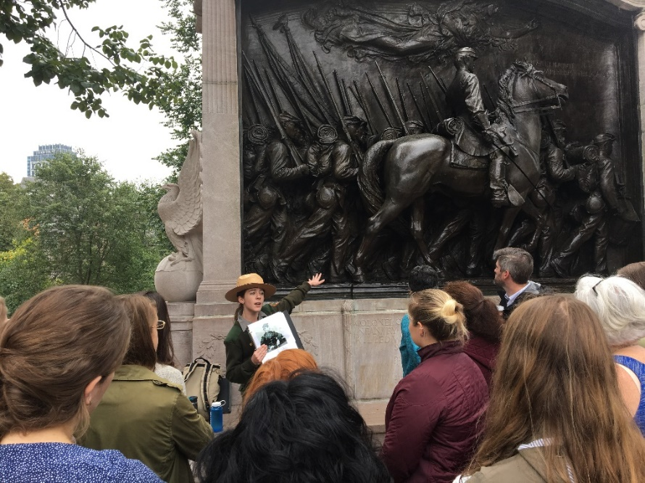
Rangers Choice in the Great Hall
Faneuil Hall
On the half-hour, Rangers offer a deeper dive into a variety of specific topics, including the MA 54th Regiment, the struggle for equal education, and the role of the North Slope in the Abolition Movement.

Mobile Shaw
A mobile, interactive vehicle will serve as a pop-up Visitor Center and host to a variety of Shaw-related programs and conversations on the Boston Common and at festival sites throughout Boston.

Speaker Series
Throughout the year at various locations in Boston
Develop a variety of lectures around topics related to the Shaw/54th Memorial by leveraging local researchers and historians to share their knowledge and foster conversations with visitors and residents of Boston.

“I Will Not Die a Coward”
Weekend mornings in the summer
A living history program explores what life would have been like for a soldier of the 54th Massachusetts Regiment as they prepared for, participated in, and dealt with the consequences of battle. After signing “enlistment papers,” participants can try on reproduction uniforms and examine various historic artifacts that provide multi-sensory avenues for deepening understand why soldiers fought in the Civil War and how they coped with the cost of war.

Boston’s Black Regiment
While only a handful of the over 1,000 soldiers of the 54th came from Boston, their stories provide deep insight into why these men enlisted. Come hear their stories and learn how the North Slope of Boston prepared these men for the Civil War.

